1)API connection between Jenkins and GitHub repo
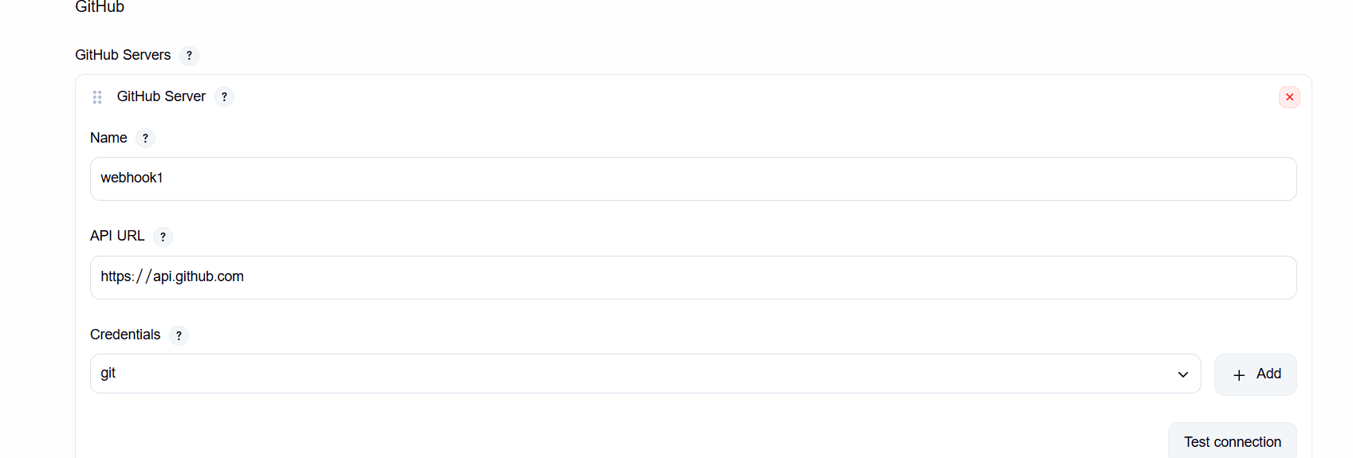

2)three jobs with configuration
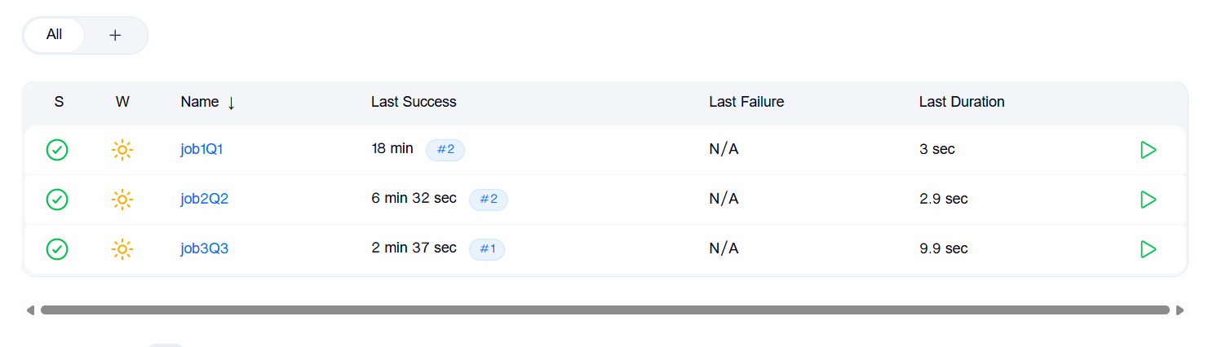

- Job1Q1

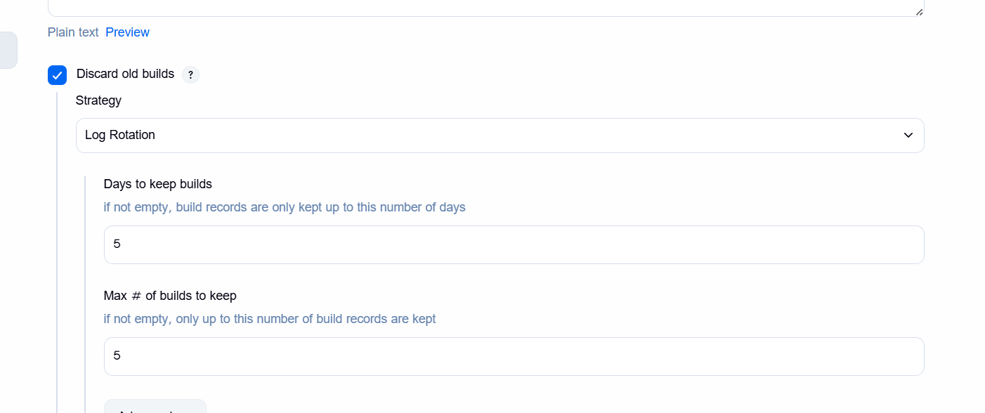

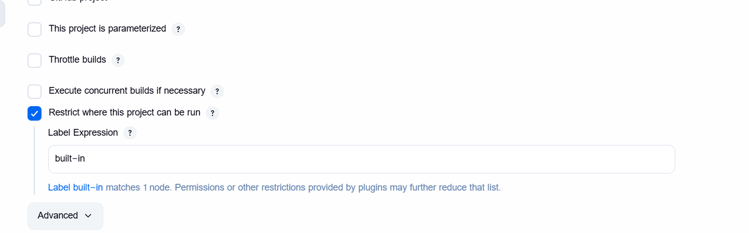

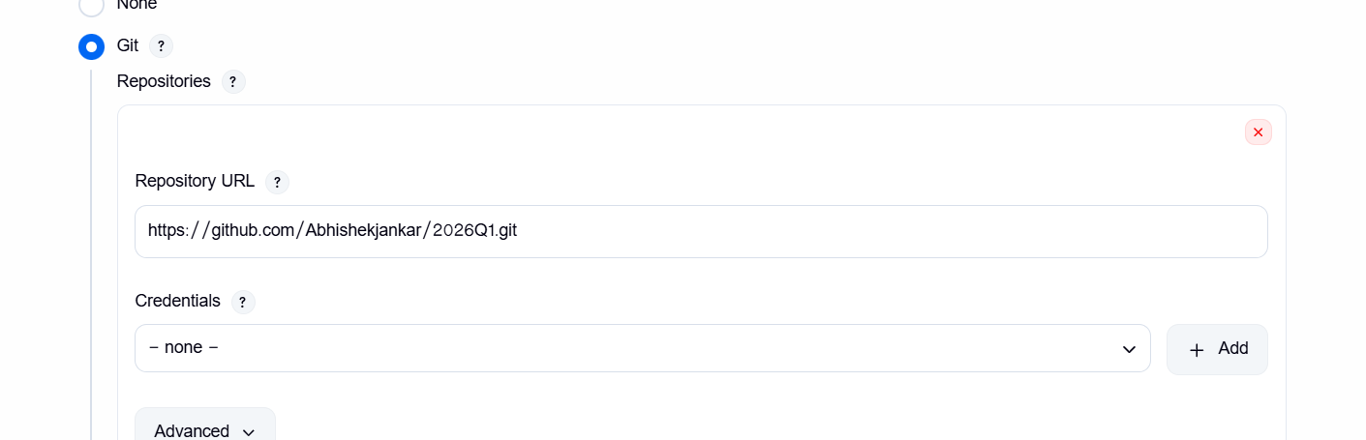

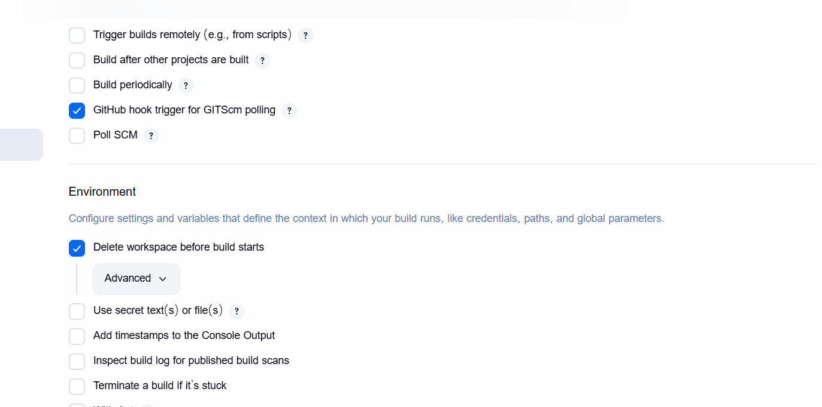

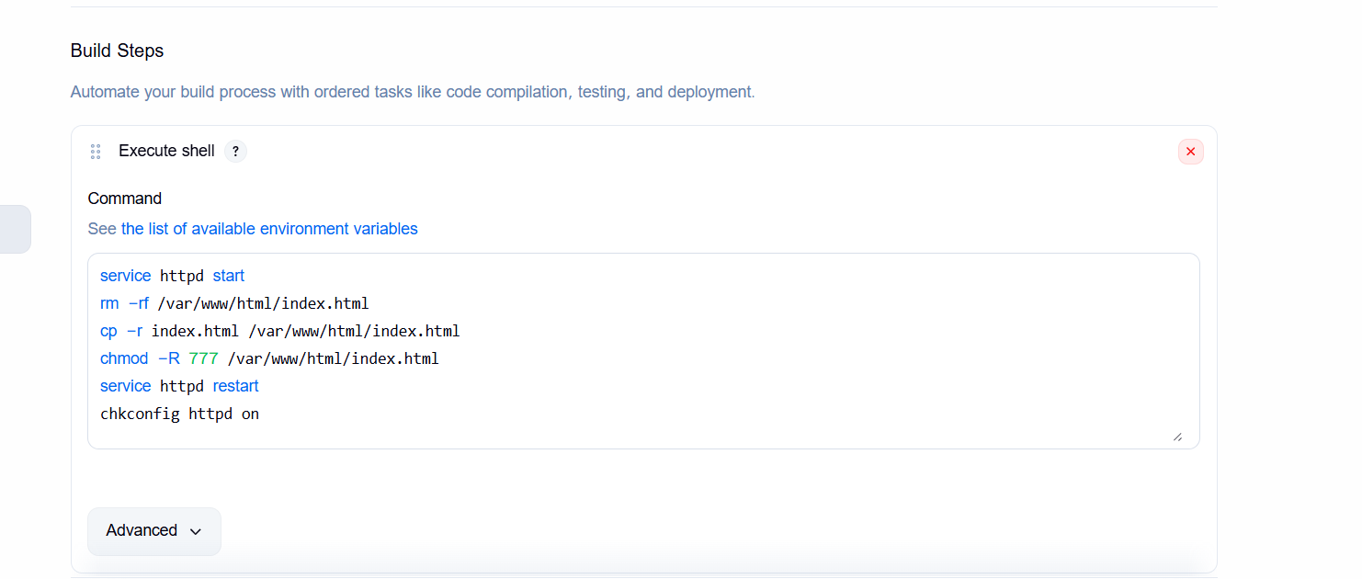

service httpd start
rm -rf /var/www/html/index.html
cp -r index.html /var/www/html/index.html
chmod -R 777 /var/www/html/index.html
service httpd restart
chkconfig httpd on

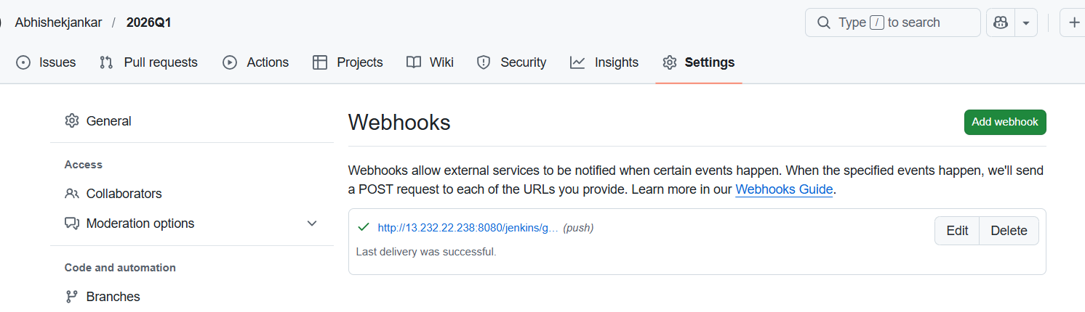

- Job2Q2
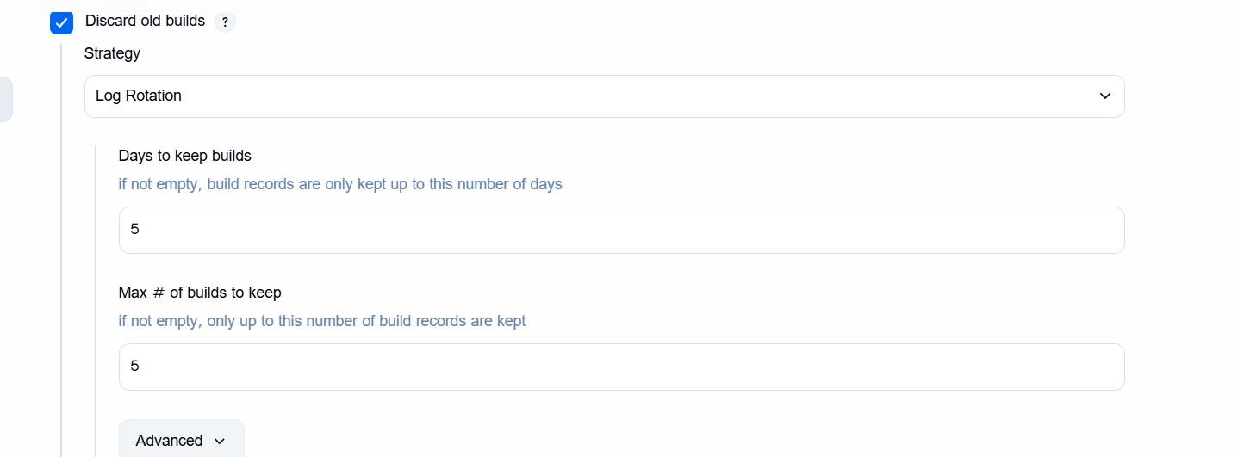
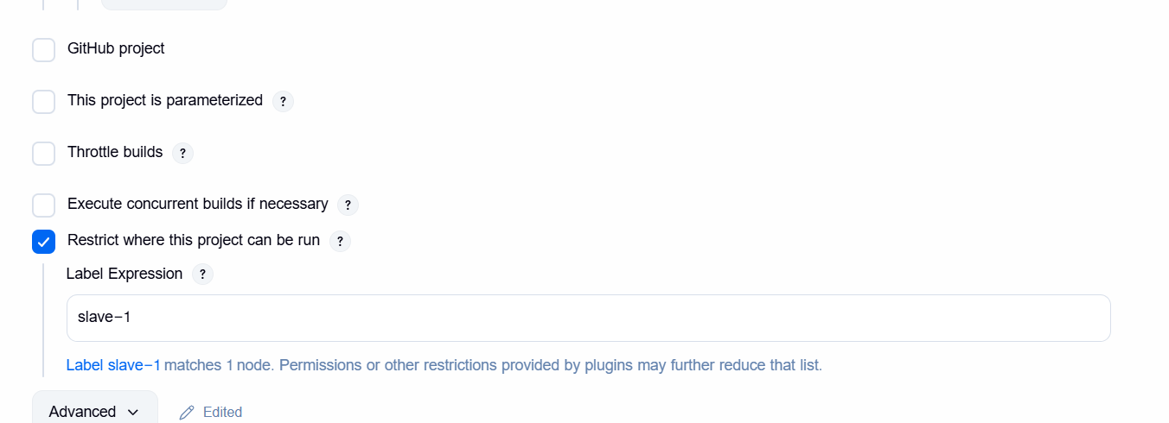

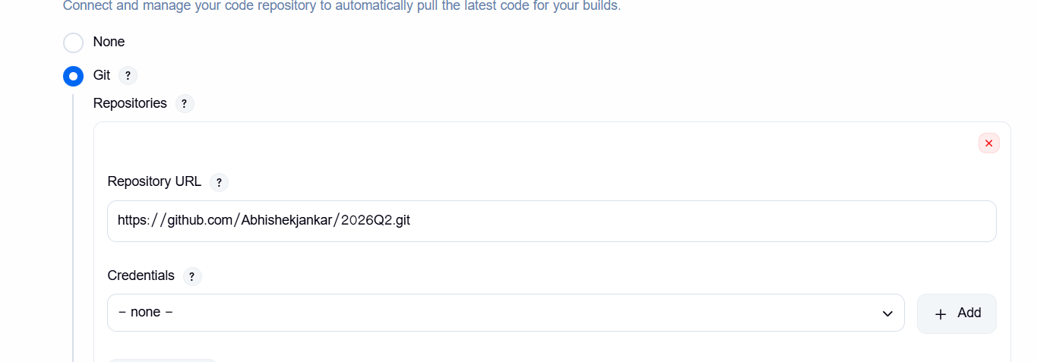

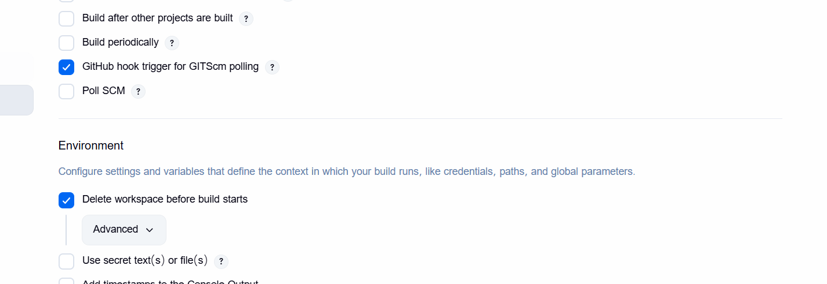

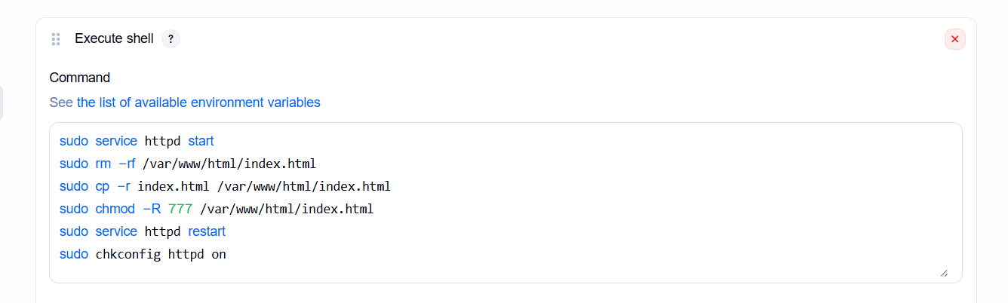
sudo service httpd start
sudo rm -rf /var/www/html/index.html
sudo cp -r index.html /var/www/html/index.html
sudo chmod -R 777 /var/www/html/index.html
sudo service httpd restart
sudo chkconfig httpd on

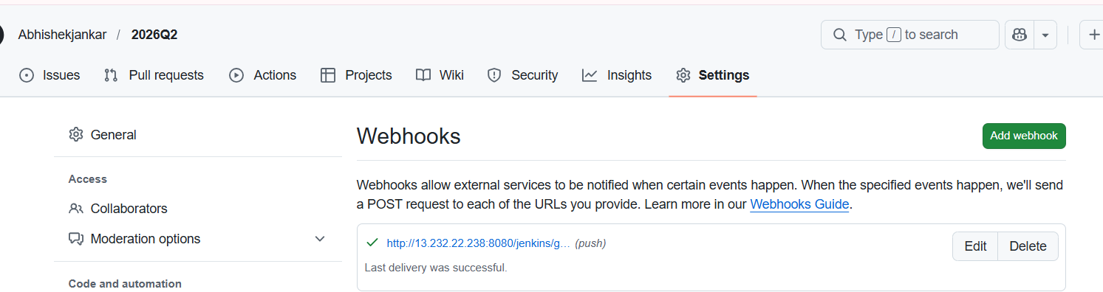

- Job3Q3
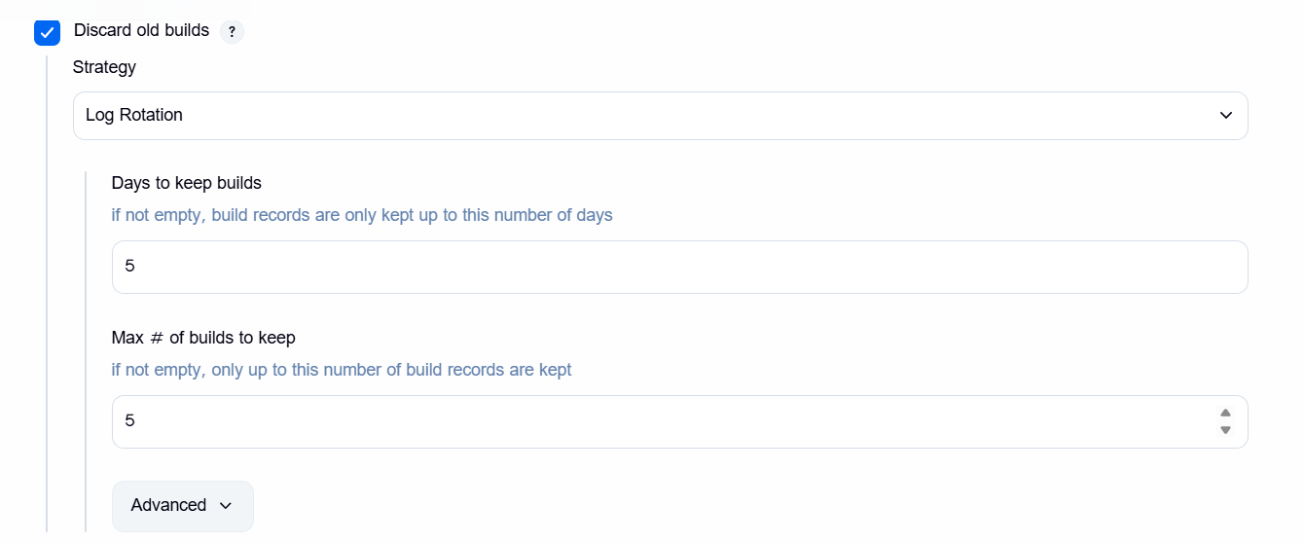

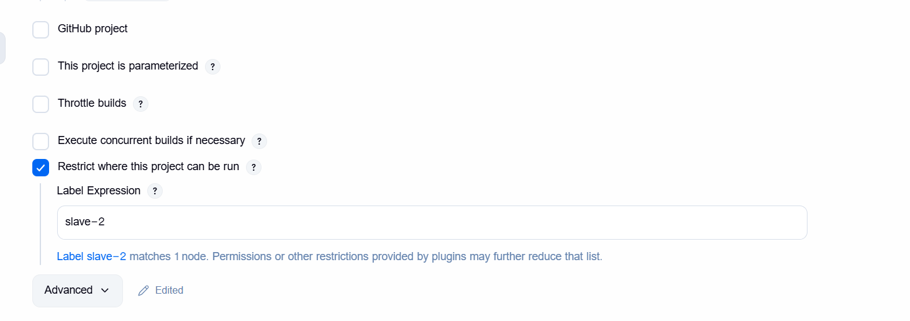

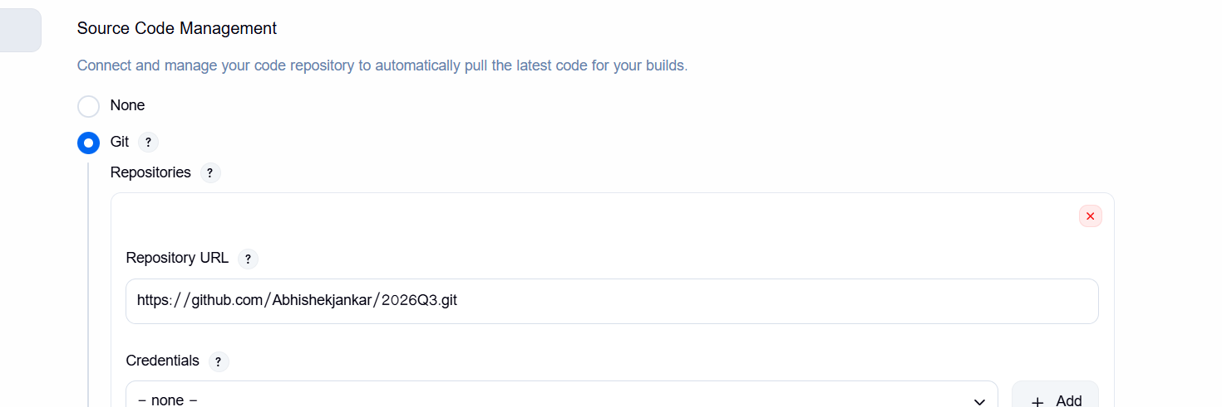

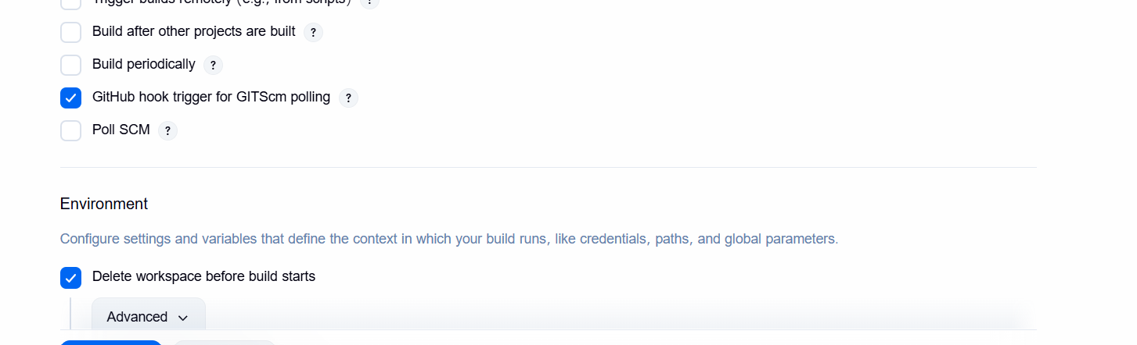
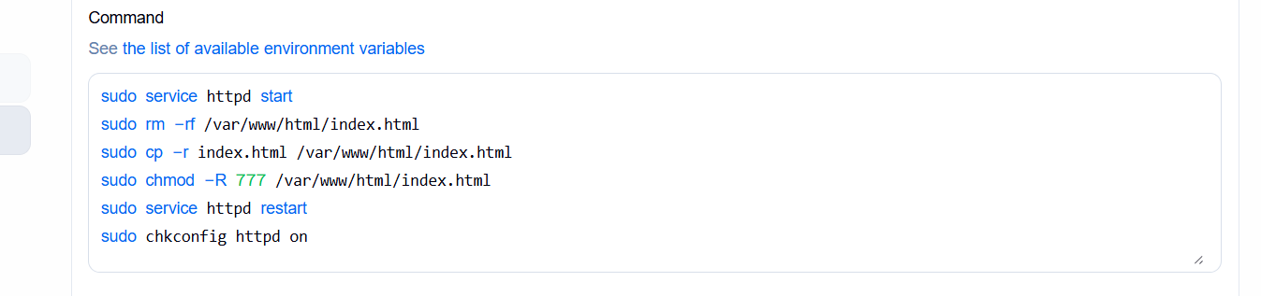

sudo service httpd start
sudo rm -rf /var/www/html/index.html
sudo cp -r index.html /var/www/html/index.html
sudo chmod -R 777 /var/www/html/index.html
sudo service httpd restart
sudo chkconfig httpd on

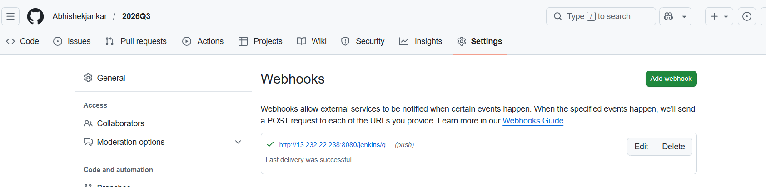

- When I change in repo 2026Q1

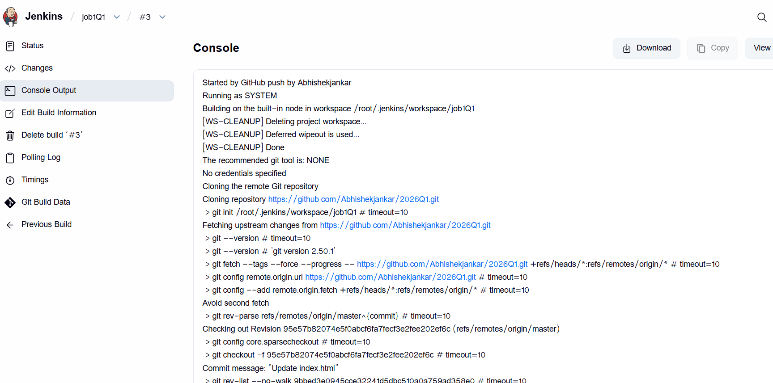
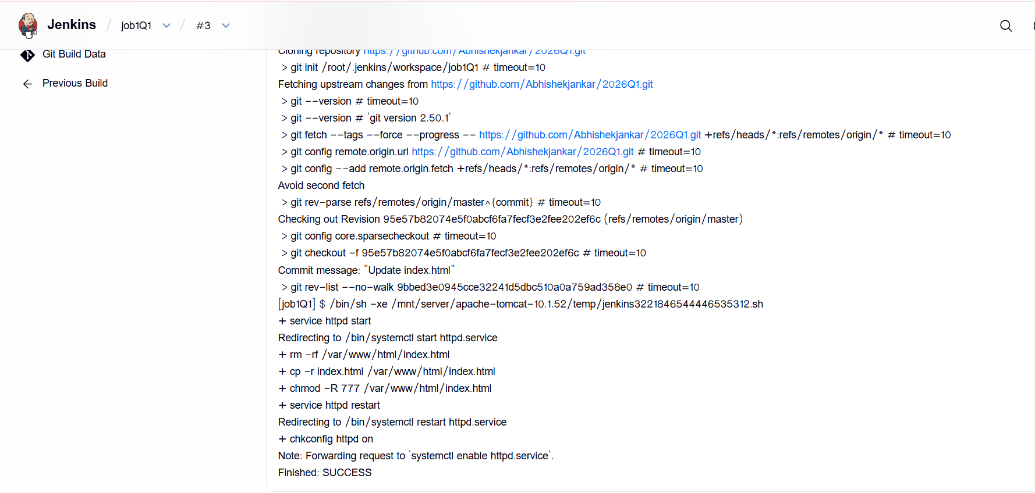

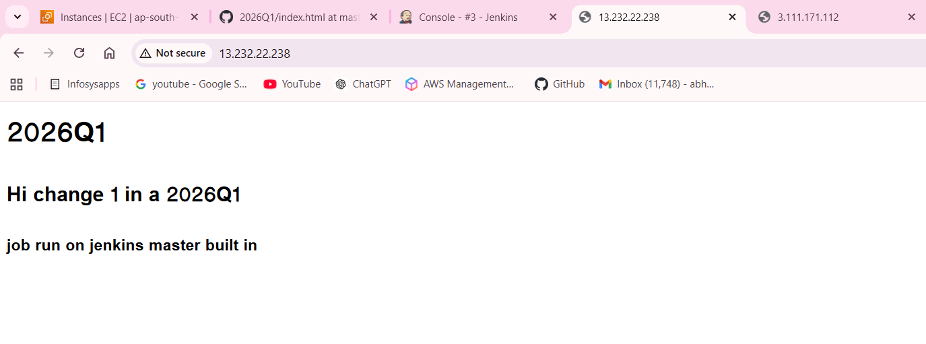

- When I change in repo 2026Q2

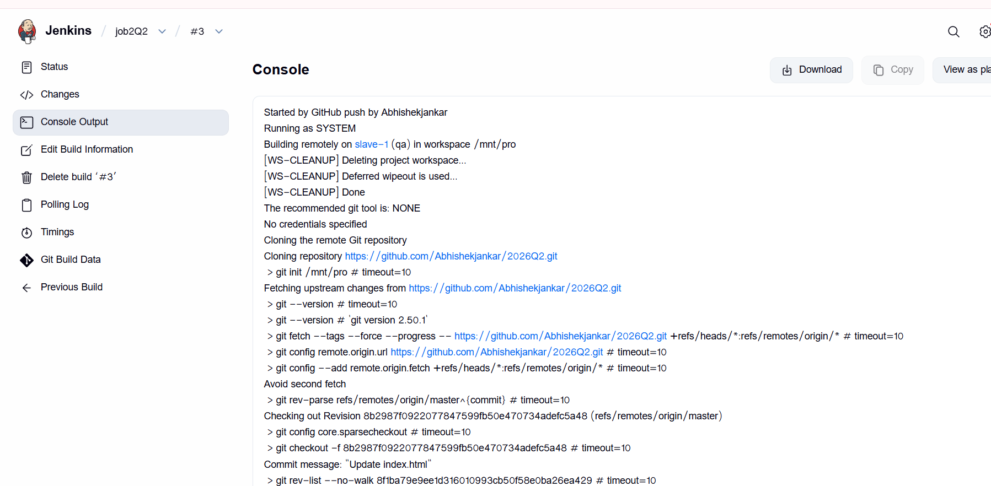

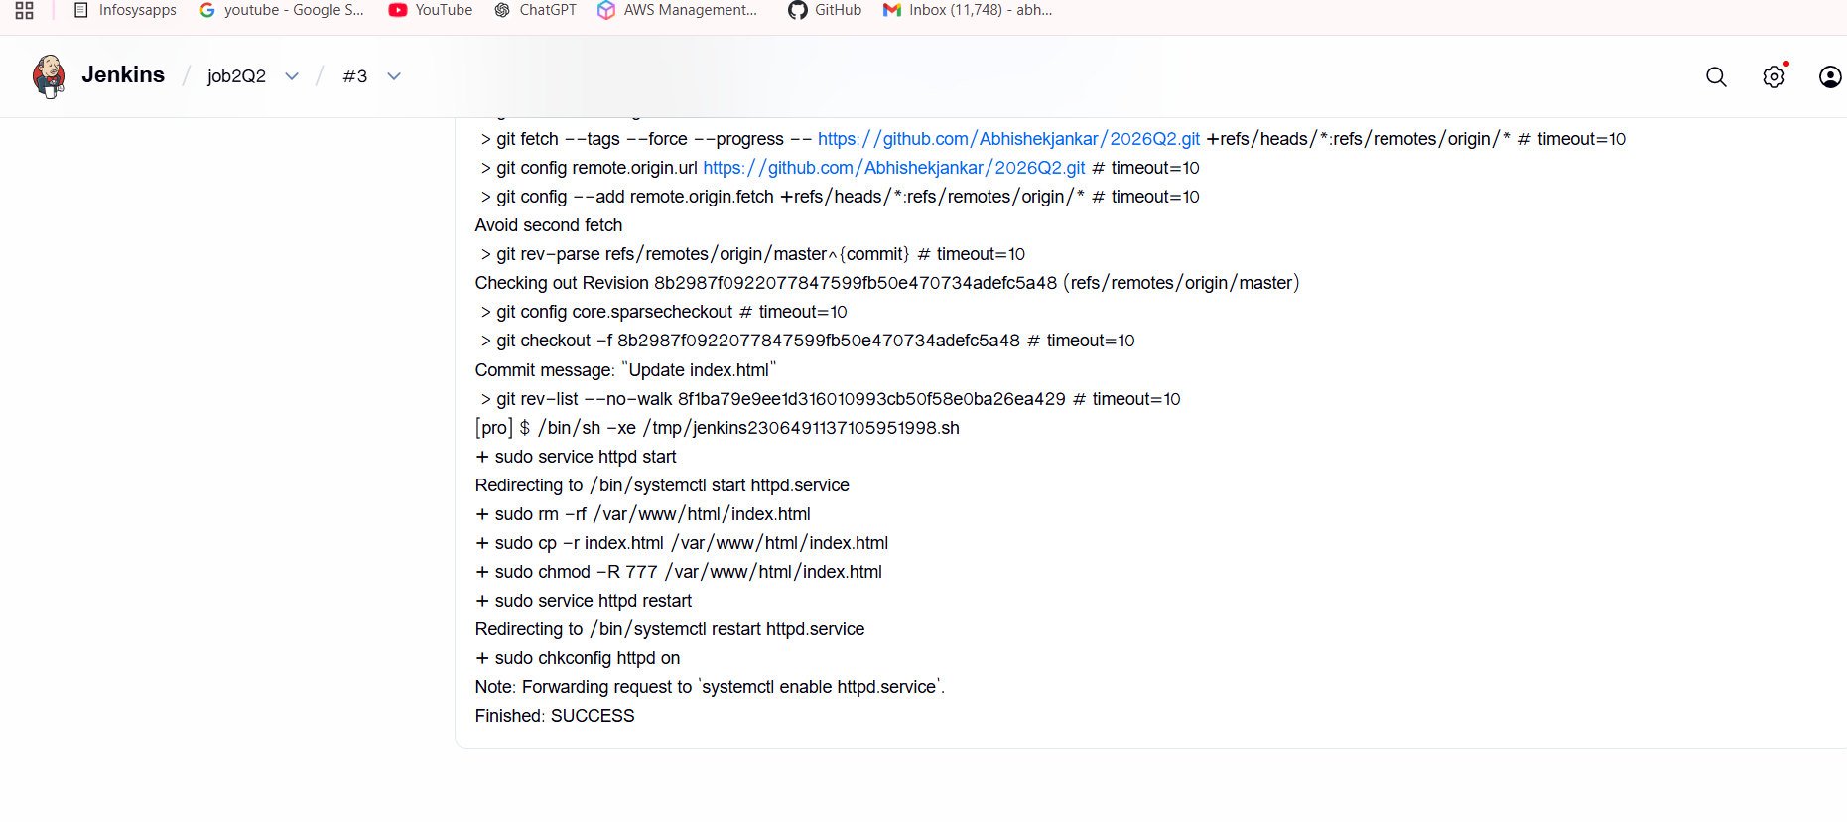

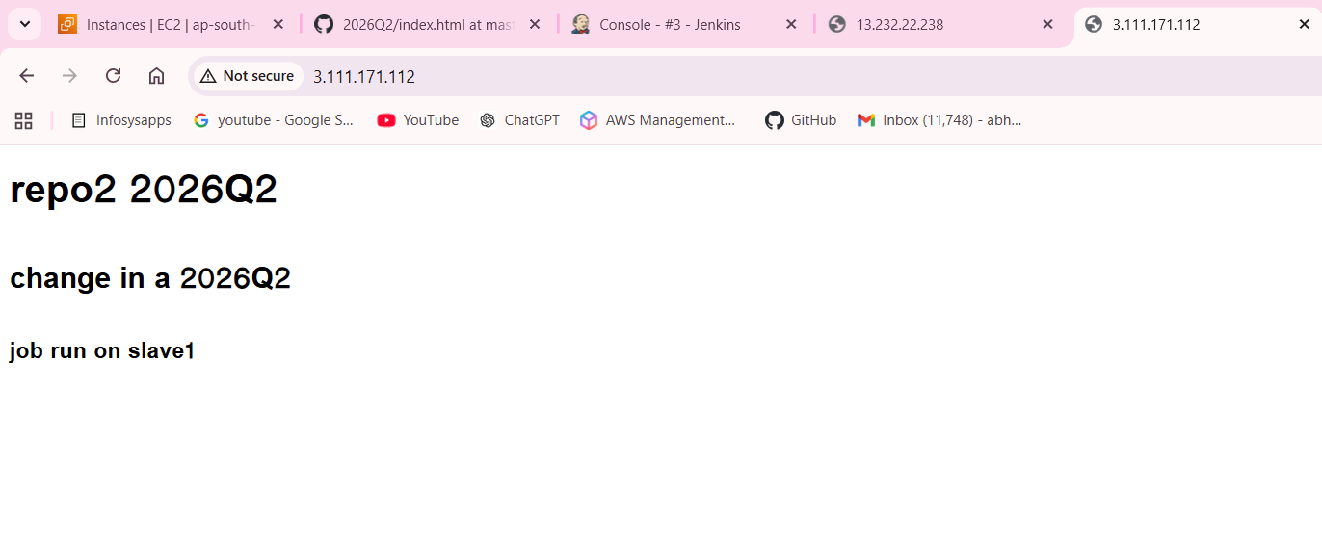

- When I change in repo 2026Q3

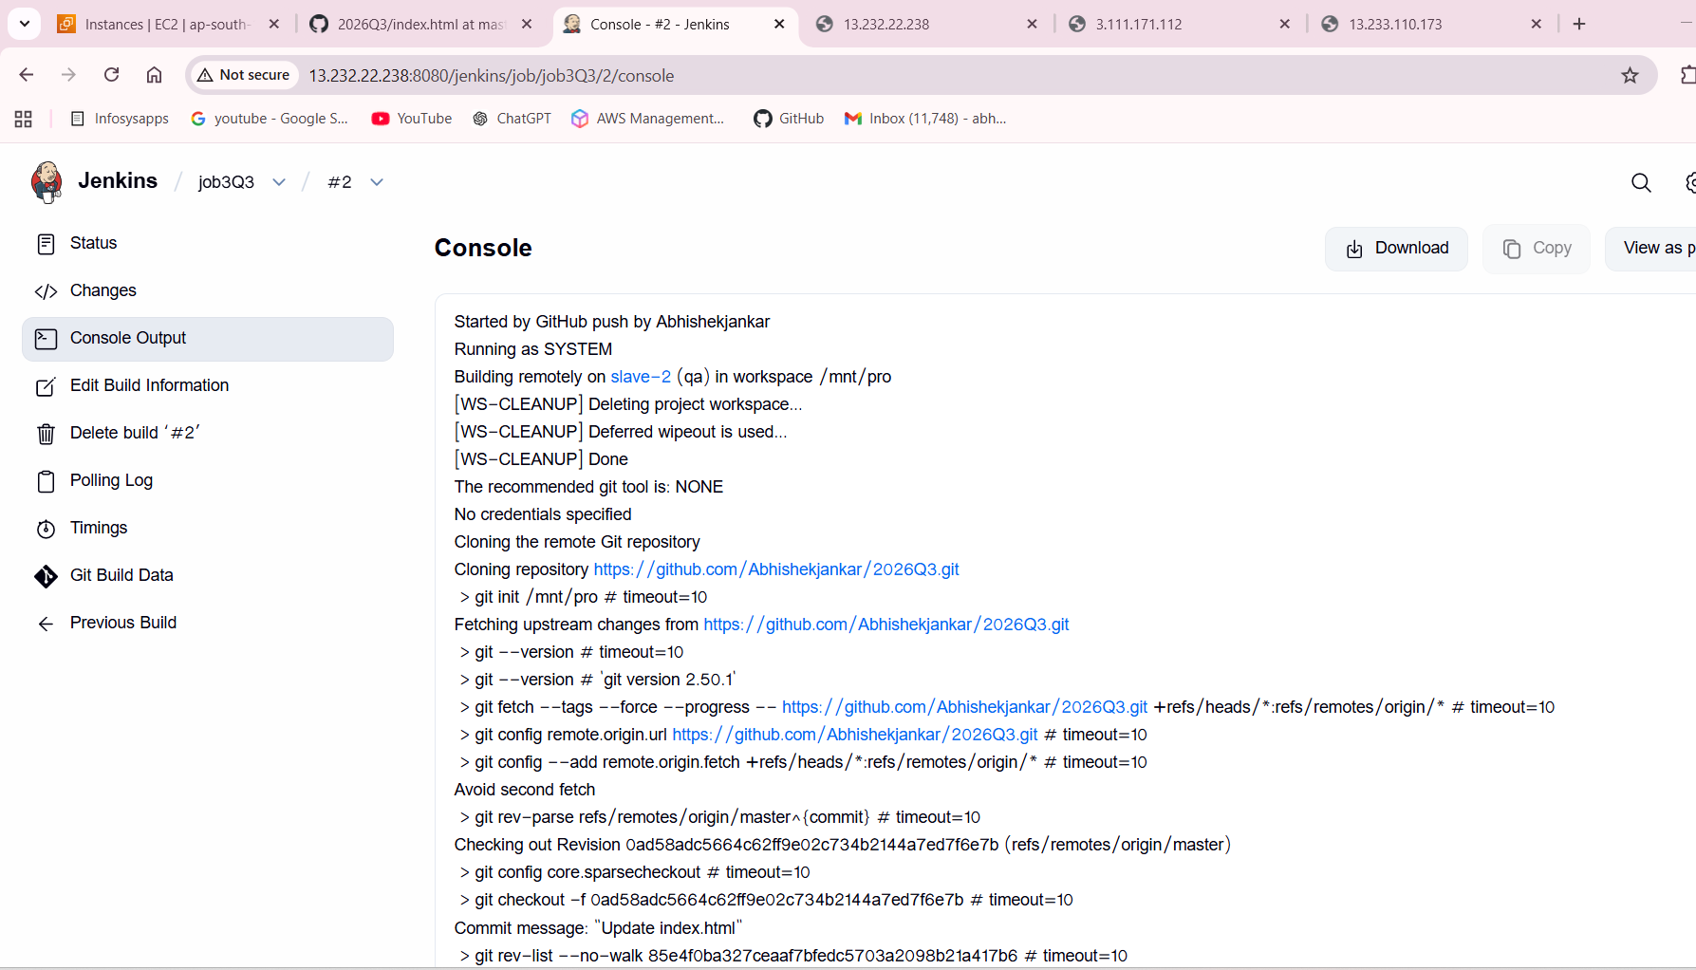

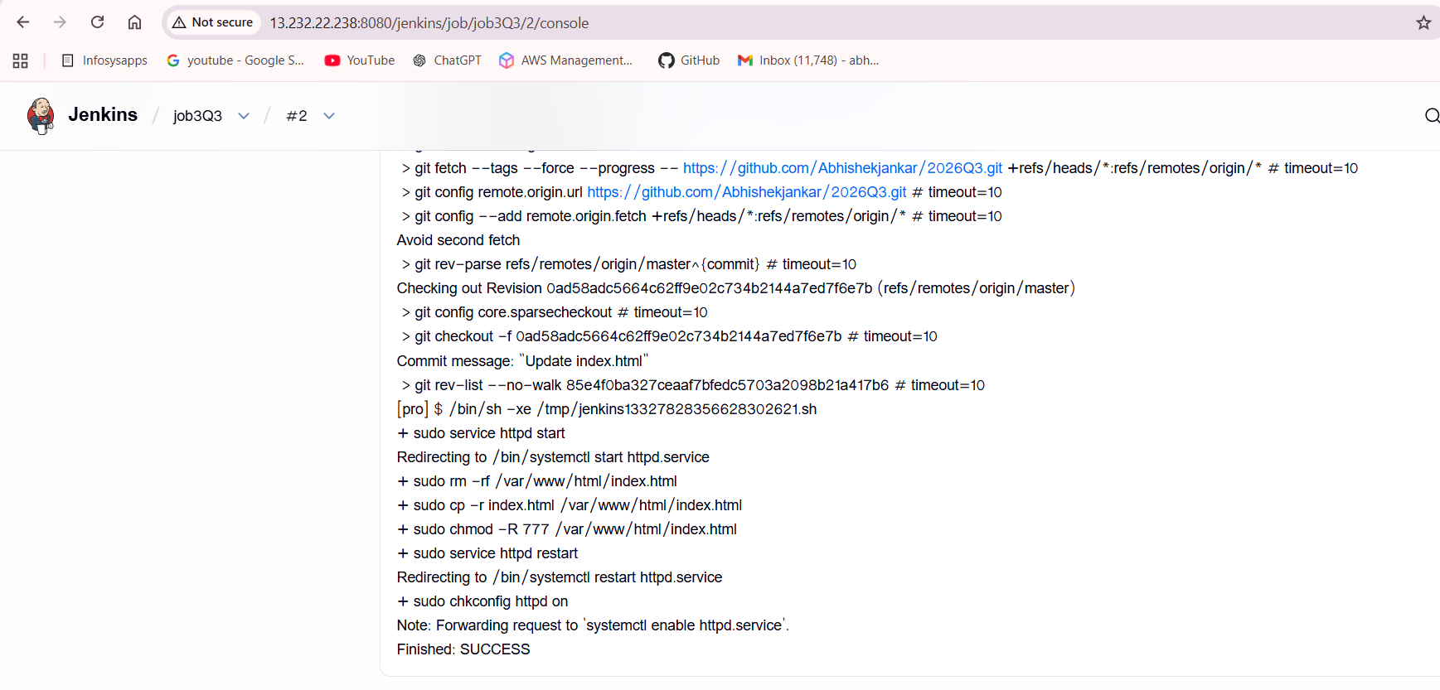

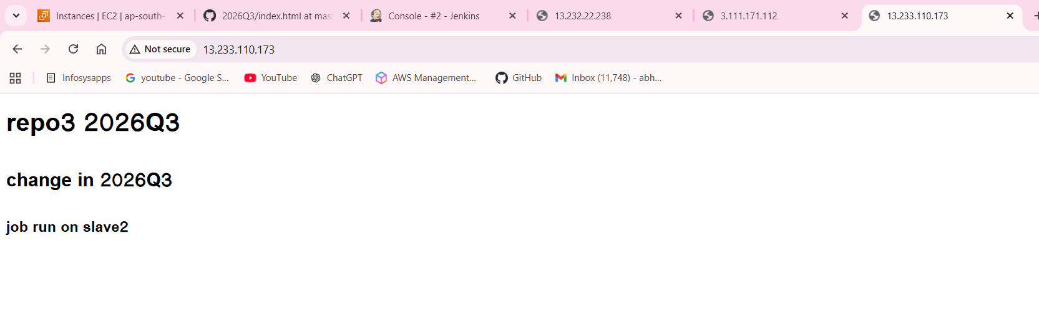

Imp points to remember —

- on Jenkins master – installed java, git, tomcat, Jenkins, httpd and full permission to tomcat
- on slave 1 – installed java, git, httpd, created one folder under /mnt/Jenkins-slave and full permission to /mnt and remember add Sudo privileges to shell commands.
- on slave 2 - installed java, git, httpd, created one folder under /mnt/Jenkins-slave and full permission to /mnt and add Sudo privileges to shell commands.

- and created webhook API connection between Jenkins master and repositories

